Introduction

BuildCert certificate holders are entitled to make use of the relevant Scheme and BuildCert logo to endorse listed products. This guidance document details how these logos can and cannot be used and the responsibility of certificate holders.

BuildCert operates the following Scheme’s which have logo’s that can be used by certificate holders as applicable.

The Scheme logos can be obtained from BuildCert upon request.

________________________________________________________________________

Thermostatic Mixing Valve Schemes 2 & 3

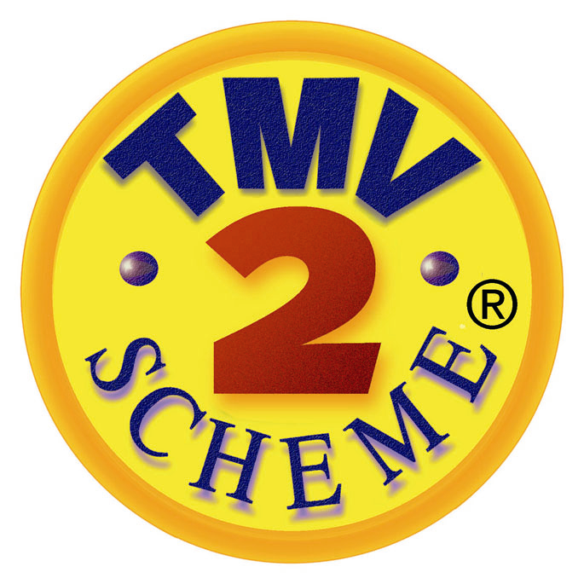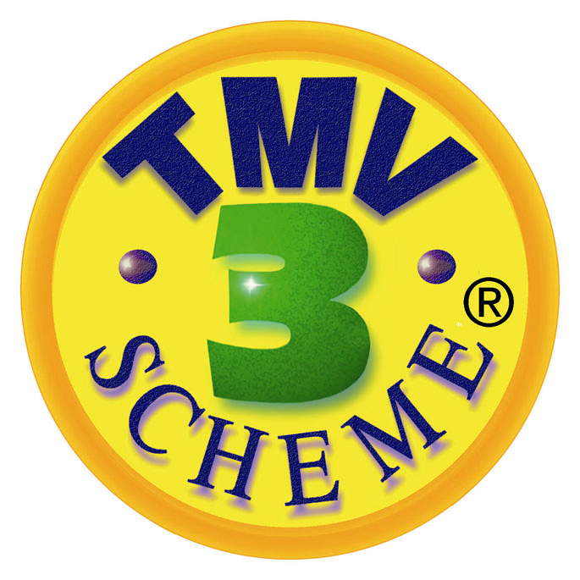

Thermostatic Mixing Valve Scheme 2 Thermostatic Mixing Valve Scheme 3

The ‘BuildCert’ name and logo, ‘TMV2 Scheme’ logo, and ‘TMV3 Scheme’ logo are registered marks of BuildCert Limited.

The following guidance, in addition to that provided by law for registered marks, has been agreed by the BuildCert Approvals Scheme.

- A 3rd party can claim TMV2 or TMV3 approval if the approved products unique reference number and licence holder’s name, as stated on the approval certificate, are used adjacent to any and all logos and be referred to in all product literature that claims TMV2 or TMV3 approval. The identification found on the valve must be exactly the same as that found on the original approval with no additions.

- The TMV2 or TMV3 logo must be positioned adjacent to the exact approved valve and not used to imply that all valves have TMV approval. If the logo is used remotely then a caveat is required under the logo that states the unique model number of the approved valve.

- The use of the words TMV2 or TMV3 approval ‘pending’ or ‘applied for’ is not acceptable.

- The following words are acceptable ‘TMV2 or TMV3 approval will be available from launch’.

- The use of ‘TMV2’ or ‘TMV3’ as a model number is not acceptable.

In the event of misuse of the Scheme logos, BuildCert name or a false claim that a product is approved by the Scheme, the following steps will be undertaken :

1. The Secretary of the Scheme will be notified of the misuse or false claim.

2. The Secretary will contact the company making the false claims to ascertain whether it manufactures the valve or purchases the valve from a manufacturer. If it purchases the valve from a manufacturer, the Secretary will ascertain whether the manufacturer has TMV2/3 approval.

3. If the manufacturer has approval see Step 4. If the valve has no TMV2/3 approval via either the manufacturer or the company then the Secretary will explain the requirements of the TMV2/3 Scheme and indicate how the company is misusing the logo or name of the Scheme. If the company is willing to submit an application for approval, then go to Steps 5 and 7. If the company is not willing to submit an application then go to Steps 5 and 6.

4. If the valve has TMV2 or TMV3 approval via the manufacturer but if the company is making false claims, then the Secretary will explain the requirements as Step 3 and will contact the TMV2 or TMV3 licence holder and notify it of the false claims. See Step 8.

5. Any manufacturer or company that makes any false claims in relation to the BuildCert logos, name or Scheme is required to make a retraction in the publication where the false claims have been made.

6. Depending upon the response to initial enquiries, the Scheme solicitor may be called to formally notify the manufacturer or company of the misuse of the TMV logo or name and will take any such steps as may be deemed necessary by the Scheme.

7. In a case of misuse, if the company has included within an advert the name of the product then the Scheme requires that the product(s) name be changed prior to any future approval by the Scheme. This will usually involve literature changes and change to the identification on the valve.

- If the company making the false claims will not make an application for approval then the manufacturer that has TMV2 or TMV3 approval will be contacted and will be asked to exert pressure upon the company to submit an application and to comply with Steps 5 and 7. If the company will not comply then the licence from the manufacturing company might be withdrawn after consultation with the Scheme solicitor. See Step 6.

9. The members of the Scheme’s Technical Assessment Panel (TAP) will be kept informed of any misuse issues. After each verified misuse of the Scheme’s Registered Mark(s) the TAP may issue 1 penalty point to any existing Scheme member, this penalty point will remain valid for 5 years, after which time it will be deleted. Any penalty points issued will be notified to the BuildCert Advisory Committee.

10. Any Scheme member that has three penalty points will have all their current incidents of misuse reviewed by the TAP who will advise the BuildCert Advisory Committee upon whether further action against the Scheme member is required. The Advisory Committee would then review the misuse incidents that make up the three or more penalty points, and if necessary, suspend approval of one or more products for a period of not more than 12 months.

________________________________________________________________________

Chemical Inhibitor Approval Scheme

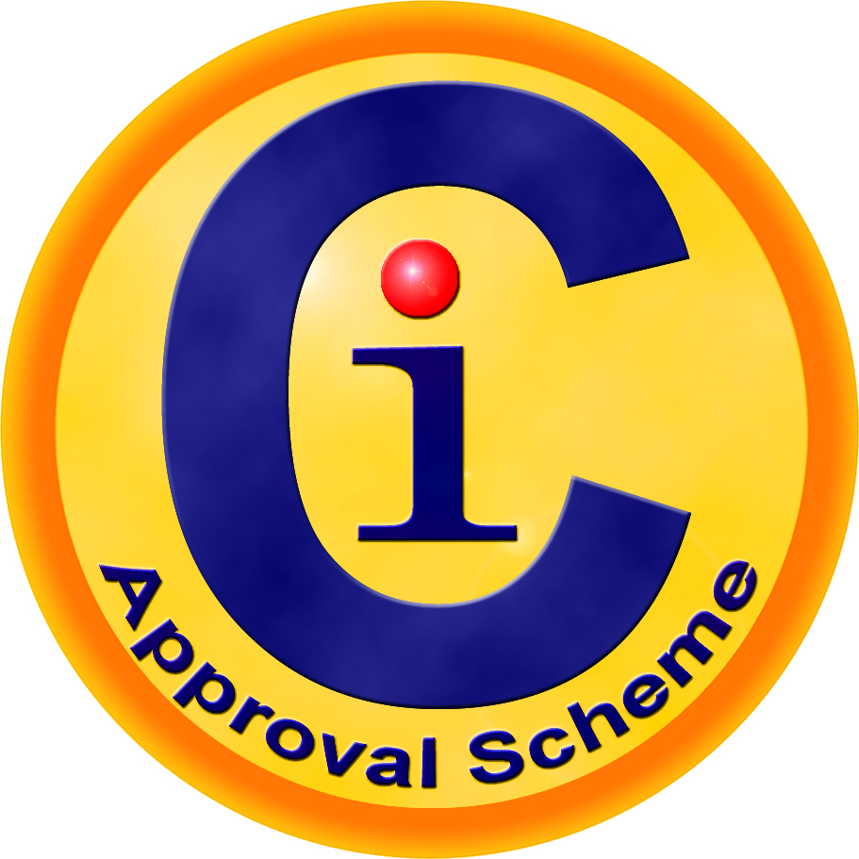

Chemical Inhibitor Approval Scheme

The ‘BuildCert’ name, logo and ‘CIAS Scheme’ are registered marks of BuildCert Limited.

The following guidance, in addition to that provided by law for registered marks, has been agreed by the BuildCert Approvals Scheme.

- A 3rd party can claim CIAS approval if the approved products unique reference number and licence holder’s name, as stated on the approval certificate, are used adjacent to the logo and be referred to in all product literature that claims CIAS approval.

- Within product literature the CIAS logo must be positioned adjacent to the exact approved product and not used to imply that all products have approval. If the logo is used remotely then a caveat is required under the logo that states the unique product details of the approved product.

- The use of the words CIAS approval ‘pending’ or ‘applied for’ is not acceptable.

- The following words are acceptable ‘CIAS approval will be available from launch’.

In the event of misuse of the Scheme logo, BuildCert name or a false claim that a product is approved by the Scheme, the following steps will be undertaken :

1. The Secretary of the Scheme will be notified of the misuse or false claim.

2. The Secretary will contact the company making the false claims to ascertain whether it manufactures the product or purchases the product from the manufacturer. If it purchases the product from a manufacturer, the Secretary will ascertain whether the manufacturer has CIAS approval.

3. If the manufacturer has approval see Step 4. If the product has no CIAS approval via either the manufacturer or the company then the Secretary will explain the requirements of the CIAS and indicate how the company is misusing the logo or name of the Scheme. If the company is willing to submit an application for approval, then go to Steps 5 and 7. If the company is not willing to submit an application then go to Steps 5 and 6.

4. If the product has CIAS approval via the manufacturer but the company is making false claims, then the Secretary will explain the requirements as Step 3 and will contact the CIAS licence holder and notify it of the false claims. See Step 8.

5. Any manufacturer or company that makes any false claims in relation to the BuildCert logos, name or Scheme is required to make a retraction in the publication where the false claims have been made.

6. Depending upon the response to initial enquiries, the Scheme solicitor may be called to formally notify the manufacturer or company of the misuse of the logo or name and will take any such steps as may be deemed necessary by the Scheme.

7. In a case of misuse, if the company has included within an advert the name of the product then the Scheme requires that the product(s) name be changed prior to any future approval by the Scheme. This will usually involve literature changes and change to the identification on the product.

- If the company making the false claims will not make an application for approval then the manufacturer that has CIAS approval will be contacted and will be asked to exert pressure upon the company to submit an application and to comply with Steps 5 and 7. If the company will not comply then the licence from the manufacturing company might be withdrawn after consultation with the Scheme solicitor. See Step 6.

- The members of the Schemes Technical Assessment Panel (TAP) will be kept informed of any misuse issues if appropriate.

________________________________________________________________________

Distributing Tempering Valve Scheme

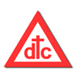

The ‘BuildCert’ name, logo and ‘DTC Scheme’ are registered marks of BuildCert Limited.

The following guidance, in addition to that provided by law for registered marks, has been agreed by the BuildCert Approvals Scheme.

- A 3rd party can claim DTC approval if the approved products unique reference number and licence holder’s name, as stated on the approval certificate, are used adjacent to any and all logos and be referred to in all product literature that claims DTC approval.

- Within product literature the DTC Scheme logo must be positioned adjacent to the exact approved product and not used to imply that all products have approval. If the logo is used remotely then a caveat is required under the logo that states the unique product details of the approved product.

- The use of the words DTC Scheme approval ‘pending’ or ‘applied for’ is not acceptable.

- The following words are acceptable ‘DTC Scheme approval will be available from launch’.

In the event of misuse of the Scheme logo, BuildCert name or a false claim that a product is approved by the Scheme, the following steps will be undertaken :

1. The Secretary of the Scheme will be notified of the misuse or false claim.

2. The Secretary will contact the company making the false claims to ascertain whether it manufactures the product or purchases the product from the manufacturer. If it purchases the product from a manufacturer, the Secretary will ascertain whether the manufacturer has DTC Scheme approval.

3. If the manufacturer has approval see Step 4. If the product has no DTC approval via either the manufacturer or the company then the Secretary will explain the requirements of the DTC Scheme and indicate how the company is misusing the logo or name of the Scheme. If the company is willing to submit an application for approval, then go to Steps 5 and 7. If the company is not willing to submit an application then go to Steps 5 and 6.

4. If the product has DTC approval via the manufacturer but the company is making false claims, then the Secretary will explain the requirements as Step 3 and will contact the DTC licence holder and notify it of the false claims. See Step 8.

5. Any manufacturer or company that makes any false claims in relation to the BuildCert logos, name or Scheme is required to make a retraction in the publication where the false claims have been made.

6. Depending upon the response to initial enquiries, the Scheme solicitor may be called to formally notify the manufacturer or company of the misuse of the logo or name and will take any such steps as may be deemed necessary by the Scheme.

7. In a case of misuse, if the company has included within an advert the name of the product then the Scheme requires that the product(s) name be changed prior to any future approval by the Scheme. This will usually involve literature changes and change to the identification on the product.

- If the company making the false claims will not make an application for approval then the manufacturer that has DTC approval will be contacted and will be asked to exert pressure upon the company to submit an application and to comply with Steps 5 and 7. If the company will not comply then the licence from the manufacturing company might be withdrawn after consultation with the Scheme solicitor. See Step 6.

- The members of the Schemes Technical Assessment Panel (TAP) will be kept informed of any misuse issues if appropriate.

________________________________________________________________________

BuildCert / UKAS Logo

BuildCert certified products may also be endorsed by use of the logo below that includes reference to the fact that BuildCert is a UKAS accredited product certification company :

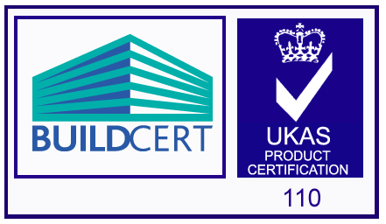

NOTE : The BuildCert / UKAS logo can only be reproduced as shown above. The BuildCert logo cannot be substituted with a Scheme log.

The BuildCert / UKAS logo can only be used when BuildCert product certification has been granted to an applicant’s product.

The BuildCert / UKAS logo can be obtained from BuildCert upon request.

Reference to the logo must be withdrawn when the product is no longer certified with BuildCert.

BuildCert certificate holders may only make use of the BuildCert / UKAS logo for certified products for which BuildCert has been accredited.

The BuildCert / UKAS logo can only be reproduced in the format and colours shown above.

BuildCert certificate holders may use the BuildCert / UKAS logo on stationery and publicity material or other items relevant to the certificate.

BuildCert certificate holders may also use the BuildCert logo without the UKAS logo if they wish.

BuildCert will review use of the certificate holders using the BuildCert / UKAS logo at regular intervals to ensure that its use is in accordance with BuildCert and UKAS ruling. If its use has been contravened, BuildCert shall take remedial steps as deemed necessary.

If physical constraints prevent reproduction of the BuildCert / UKAS logo on the certified product, a label may be attached instead. If this is impracticable, the label may be affixed to the primary packaging (eg. blister pack) but not to the secondary packaging (eg. outer, transit pack).

The BuildCert / UKAS logo shall not be displayed on buildings, flags or vehicles.

If a situation arises where BuildCert’s accreditation ceases, certificate holders will be informed by BuildCert in writing immediately. It must then follow that the certificate holder stops using the BuildCert / UKAS logo with immediate effect and removes all reference to it. The certificate holder shall confirm in writing to BuildCert its acknowledgement of this and that it will act upon it with immediate effect.

The BuildCert / UKAS logo must not be used except in connection with those products to which the BuildCert certificate applies. The certificate holder must specifically identify the products to which the certificate applies when using the logo’s in a context where the scope of the application is open to doubt.

The certificate holder undertakes to discontinue any use of the BuildCert / UKAS logo which is unacceptable to BuildCert, and any form of statement or reference to the right of the certificate holder to use the product conformity mark which in the opinion of BuildCert might be misleading.

Upon the termination of the certificate for whatever reason, the certificate holder undertakes to discontinue all use of BuildCert logo’s immediately and to erase the mark from all material and products on which it appears, including the destruction of such products as required by BuildCert.

